Journal Title

First A. Author, *Student,* Second B. Author, and Third C. Author, Jr., Professor

*Abstract*—

Font should be bolded Times New Roman 10.

# introduction

Put introduction here, in Times New Roman 10.

# title 1

Put second section here, in Times New Roman 10 (i.e. Methods, etc.)

## Subtitle 1

Put subsection here, in Times New Roman 10. Do not leave a space between subsections.

## Citations

In text citations should be represented by a number enclosed in square brackets [1]. When citing more than one source at a time, list each reference number separately with a comma between each reference [2], [3], [4].

# title 2

Put third section here, in Times New Roman 10.

## Subtitle 1

TABLE I

Units for Magnetic Properties

|  |  |  |
| --- | --- | --- |
| Symbol | Quantity | Conversion from Gaussian and  CGS EMU to SI a |
| Φ | magnetic flux | 1 Mx → 10−8 Wb = 10−8 V·s |
| *B* | magnetic flux density,  magnetic induction | 1 G → 10−4 T = 10−4 Wb/m2 |
| *H* | magnetic field strength | 1 Oe → 103/(4π) A/m |
| *m* | magnetic moment | 1 erg/G = 1 emu  → 10−3 A·m2 = 10−3 J/T |
| *M* | magnetization | 1 erg/(G·cm3) = 1 emu/cm3  → 103 A/m |
| 4π*M* | magnetization | 1 G → 103/(4π) A/m |
| σ | specific magnetization | 1 erg/(G·g) = 1 emu/g → 1 A·m2/kg |
| *j* | magnetic dipole  moment | 1 erg/G = 1 emu  → 4π × 10−10 Wb·m |
| *J* | magnetic polarization | 1 erg/(G·cm3) = 1 emu/cm3  → 4π × 10−4 T |
| χ*,* κ | susceptibility | 1 → 4π |
| χρ | mass susceptibility | 1 cm3/g → 4π × 10−3 m3/kg |
| μ | permeability | 1 → 4π × 10−7 H/m  = 4π × 10−7 Wb/(A·m) |
| μr | relative permeability | μ → μr |
| *w, W* | energy density | 1 erg/cm3 → 10−1 J/m3 |
| *N, D* | demagnetizing factor | 1 → 1/(4π) |

Vertical lines are optional in tables. Statements that serve as captions for the entire table do not need footnote letters.

Put subsection here, in Times New Roman 10. Use the following format for equations, leaving a space between text and equations:

 (1)

# title 3

Put fourth section here, in Times New Roman 10.

# title 4

Put third section here, in Times New Roman 10.

## Graphics

Most charts, graphs, and tables are one column wide (3.5 inches / 88 millimeters) or page wide (7.16 inches / 181 millimeters). The maximum height a graphic can be is 8.5 inches (216 millimeters). When choosing the height of a graphic, please allow space for a caption. Figures can be sized

between column and page widths if the author chooses, however it is recommended that figures are not sized less than column width unless when necessary.

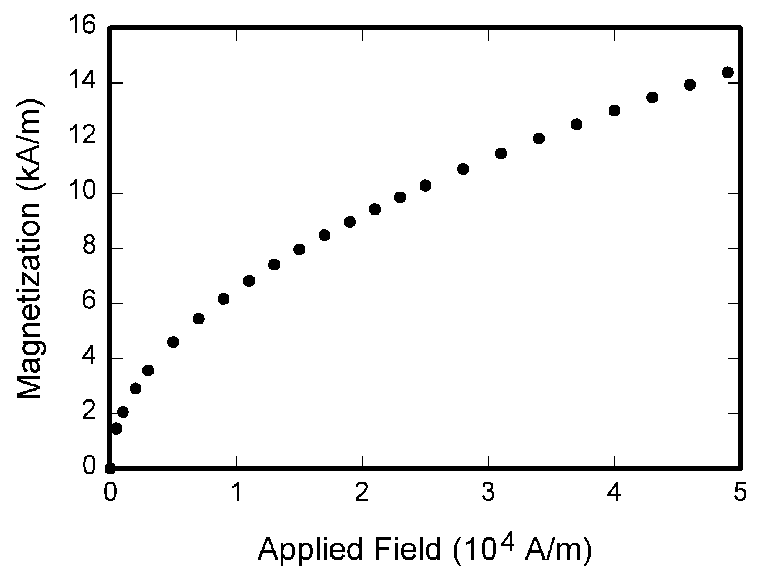

Fig. 1. Magnetization as a function of applied field. Note that “Fig.” is abbreviated. There is a period after the figure number, followed by two spaces. It is good practice to explain the significance of the figure in the caption.

# Conclusion

Acknowledgment

Put acknowledgement of help received here (i.e. PI, assisting parties).

**First A. Author** and any other authors may include biographies at the end of the paper. You may include major, minor, year of graduation, hometown, affiliations or clubs, honors and any other pertinent information. Please include your email address at the end of the biography.

References

*Basic format for* ***books****:*

1. J. K. Author, “Title of chapter in the book,” in *Title of His Published Book, x*th ed. City of Publisher, Country if not
2. USA: Abbrev. of Publisher, year, ch. *x*, sec. *x*, pp. *xxx–xxx.*

*Examples:*

1. G. O. Young, “Synthetic structure of industrial plastics,” in *Plastics,* 2nd ed., vol. 3, J. Peters, Ed. New York: McGraw-Hill, 1964, pp. 15–64.
2. W.-K. Chen, *Linear Networks and Systems.* Belmont, CA: Wadsworth, 1993, pp. 123–135.

*Basic format for* ***periodicals****:*

1. J. K. Author, “Name of paper,” *Abbrev. Title of Periodical*, vol. *x,* no. *x,* pp*. xxx-xxx,* Abbrev. Month, year.

*Examples:*

1. J. U. Duncombe, “Infrared navigation—Part I: An assessment   
   of feasibility,” *IEEE Trans. Electron Devices*, vol. ED-11, no. 1, pp. 34–39, Jan. 1959.
2. E. P. Wigner, “Theory of traveling-wave optical laser,” *Phys. Rev*.,   
   vol. 134, pp. A635–A646, Dec. 1965.
3. E. H. Miller, “A note on reflector arrays,” *IEEE Trans. Antennas Propagat*., to be published.

*Basic format for* ***reports****:*

1. J. K. Author, “Title of report,” Abbrev. Name of Co., City of Co., Abbrev. State, Rep. *xxx*, year.

*Examples:*

1. E. E. Reber, R. L. Michell, and C. J. Carter, “Oxygen absorption in the earth’s atmosphere,” Aerospace Corp., Los Angeles, CA, Tech. Rep. TR-0200 (4230-46)-3, Nov. 1988.
2. J. H. Davis and J. R. Cogdell, “Calibration program for the 16-foot antenna,” Elect. Eng. Res. Lab., Univ. Texas, Austin, Tech. Memo. NGL-006-69-3, Nov. 15, 1987.

*Basic format for* ***handbooks****:*

1. *Name of Manual/Handbook*, *x* ed., Abbrev. Name of Co., City of Co., Abbrev. State, year, pp. *xxx-xxx.*

*Examples:*

1. *Transmission Systems for Communications*, 3rd ed., Western Electric Co., Winston-Salem, NC, 1985, pp. 44–60.
2. *Motorola Semiconductor Data Manual*, Motorola Semiconductor Products Inc., Phoenix, AZ, 1989.

*Basic format for books (when available online):*

1. Author. (year, month day). *Title.* (edition) [Type of medium]. *volume (issue).* Available: site/path/file

*Example:*

1. J. Jones. (1991, May 10). *Networks.* (2nd ed.) [Online]. Available: [http://www.atm.com](http://www.atm.com/)

*Basic format for* ***journals (when available******online****):*

1. Author. (year, month). Title. *Journal.* [Type of medium]. *volume (issue),* pages. Available: site/path/file

*Example:*

1. R. J. Vidmar. (1992, Aug.). On the use of atmospheric plasmas as electromagnetic reflectors. *IEEE Trans. Plasma Sci.* [Online]. *21(3),* pp. 876–880. Available:<http://www.halcyon.com/pub/journals/21ps03-vidmar>

*Basic format for* ***papers presented at conferences (when available online****):*

1. Author. (year, month). Title. Presented at Conference title. [Type of Medium]. Available: site/path/file

*Example:*

1. PROCESS Corp., MA. Intranets: Internet technologies deployed behind the firewall for corporate productivity. Presented at   
   INET96 Annual Meeting. [Online]. Available: <http://home.process.com/Intranets/wp2.htp>

*Basic format for reports and handbooks (when available online):*

1. Author. (year, month). Title. Comp an y . C ity, State or Country. [Type of Medium]. Available: site/path/file

*Example:*

1. S. L. Tall een. (1996 , Apr . ). The In t r an et Archi -tecture: M a nagi ng i n f o rm at i on i n t h e ne w paradigm. Amdahl Corp., CA. [Online]. Available:<http://www.amdahl.com/doc/products/bsg/intra/infra/html>

*Basic format for computer programs and electronic documents (when available online):* ISO recommends that capitalization follow the accepted practice for the language or script in which the information is given.

*Example:*

1. A. Harriman. (1993, June). Compendium of genealogical software. *Humanist.* [Online]. Available e-mail: [HUMANIST@NYVM.ORG](mailto:HUMANIST@NYVM.ORG) Message: get GENEALOGY REPORT

*Basic format for patents (when available online):*

1. Name of the invention, by inventor’s name. (year, month day). *Patent Number* [Type of medium]. Available: site/path/file

*Example:*

1. Musical toothbrush with adjustable neck and mirror, by L.M.R. Brooks. (1992, May 19). *Patent D 326 189*

[Online]. Available: NEXIS Library: LEXPAT File: DESIGN

*Basic format for conference proceedings (published):*

1. J. K. Author, “Title of paper,” in *Abbreviated Name of Conf.*, City of Conf., Abbrev. State (if given), year, pp. *xxxxxx.*

*Example:*

1. D. B. Payne and J. R. Stern, “Wavelength-switched pas- sively coupled single-mode optical network,” in *Proc. IOOC-ECOC,* 1985,   
   pp. 585–590.

*Example for papers presented at conferences (unpublished):*

1. D. Ebehard and E. Voges, “Digital single sideband detection for interferometric sensors,” presented at the 2nd Int. Conf. Optical Fiber Sensors, Stuttgart, Germany, Jan. 2-5, 1984.

*Basic format for patents:*

1. J. K. Author, “Title of patent,” U.S. Patent *x xxx xxx*, Abbrev. Month, day, year.

*Example:*

1. G. Brandli and M. Dick, “Alternating current fed power supply,”   
   U.S. Patent 4 084 217, Nov. 4, 1978.

*Basic format**for theses (M.S.) and dissertations (Ph.D.):*

1. J. K. Author, “Title of thesis,” M.S. thesis, Abbrev. Dept., Abbrev. Univ., City of Univ., Abbrev. State, year.
2. J. K. Author, “Title of dissertation,” Ph.D. dissertation, Abbrev. Dept., Abbrev. Univ., City of Univ., Abbrev. State, year.

*Examples:*

1. J. O. Williams, “Narrow-band analyzer,” Ph.D. dissertation, Dept. Elect. Eng., Harvard Univ., Cambridge, MA, 1993.
2. N. Kawasaki, “Parametric study of thermal and chemical nonequilibrium nozzle flow,” M.S. thesis, Dept. Electron. Eng., Osaka Univ., Osaka, Japan, 1993.

*Basic format for the most common types of unpublished references:*

1. J. K. Author, private communication, Abbrev. Month, year.
2. J. K. Author, “Title of paper,” unpublished.
3. J. K. Author, “Title of paper,” to be published.

*Examples:*

1. A. Harrison, private communication, May 1995.
2. B. Smith, “An approach to graphs of linear forms,” unpublished.
3. A. Brahms, “Representation error for real numbers in binary computer arithmetic,” IEEE Computer Group Repository, Paper R-67-85.

*Basic format for standards:*

1. *Title of Standard*, Standard number, date.

*Examples:*

1. IEEE Criteria for Class IE Electric Systems, IEEE Standard 308, 1969.
2. Letter Symbols for Quantities, ANSI Standard Y10.5-1968.